**MONGODB TASK**

**CREATING DB COMMANDS AND INSERT:**

**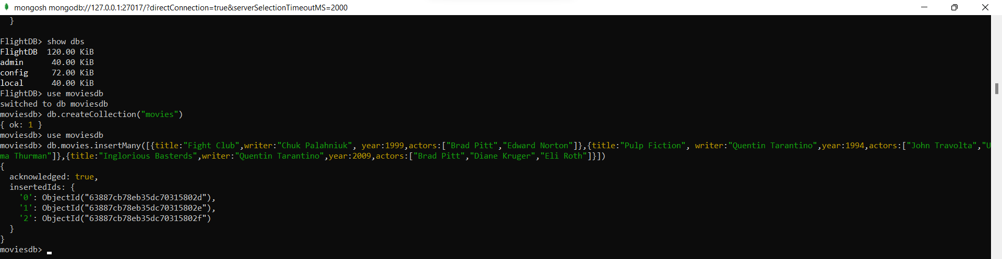  
INSERT COMMANDS:**

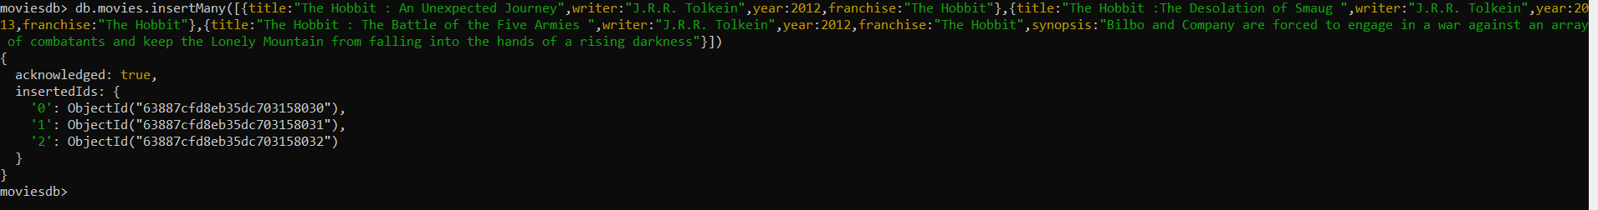

**GET ALL DOCUMENTS:**

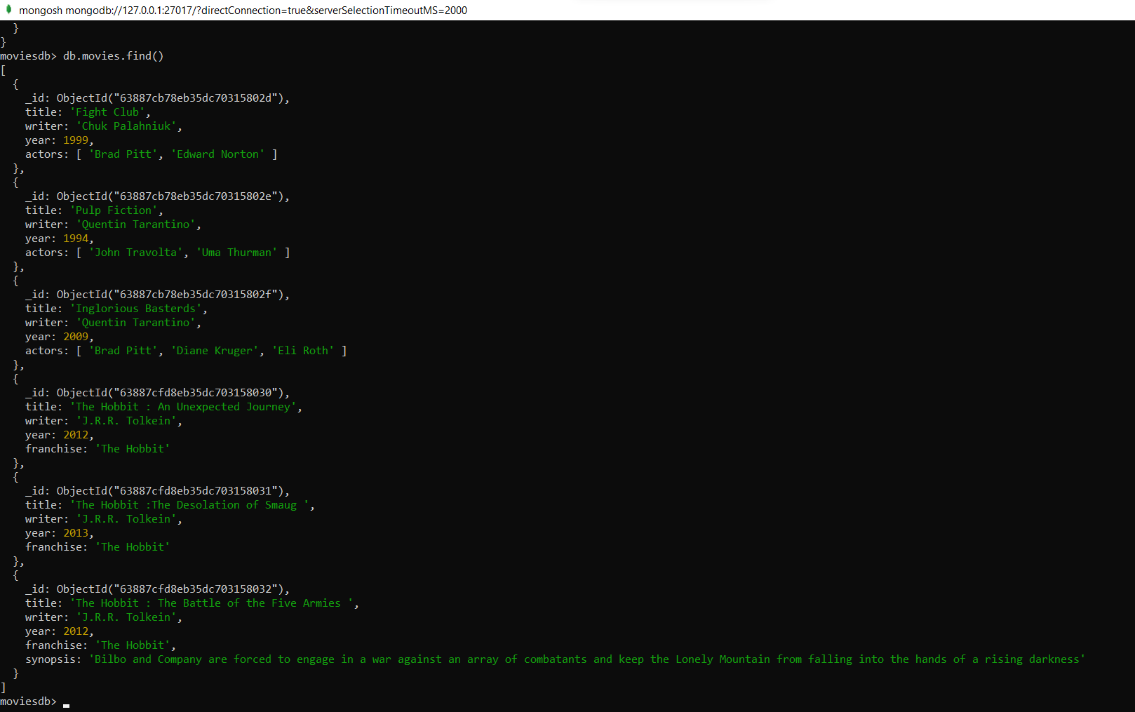

**GET ALL DOCUMENTS WITH WRITER SET TO "QUENTIN TARANTINO"**

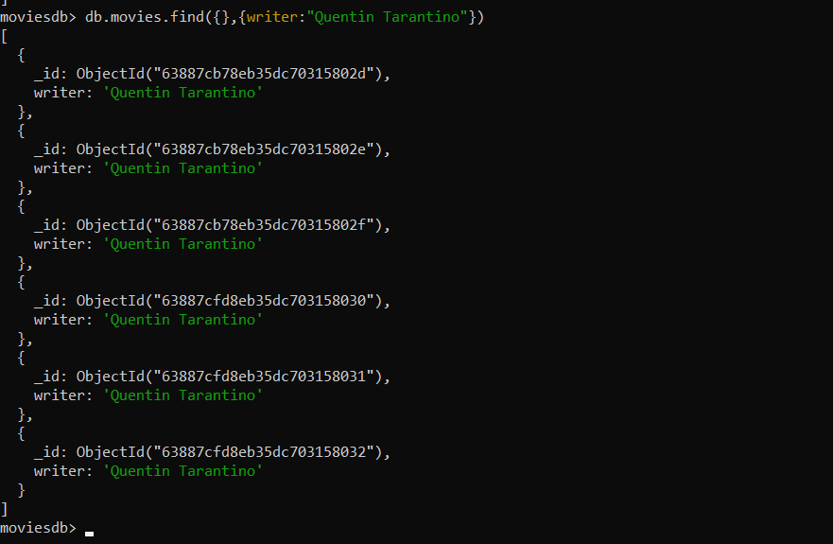

**GET ALL DOCUMENTS WHERE ACTORS INCLUDE BRAD PITT**

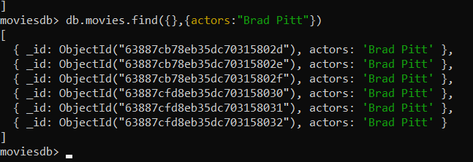

**GET ALL DOCUMENTS WITH FRANCHISE SET TO "THE HOBBIT"**

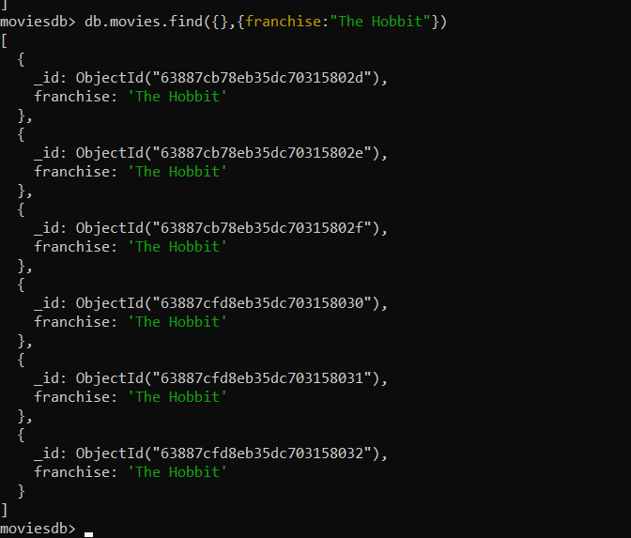

**GET ALL MOVIES RELEASED IN THE 90S**

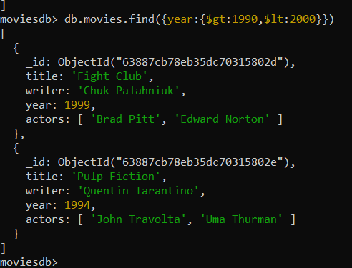

**GET ALL MOVIES RELEASED BEFORE THE YEAR 2000 OR AFTER 2010**

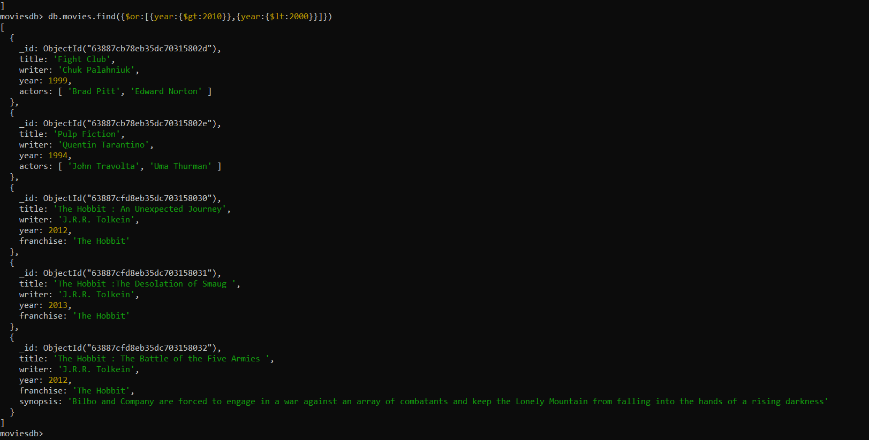

**COUNT THE NUMBER OF WRITER FROM THE MOVIE COLLECTION**

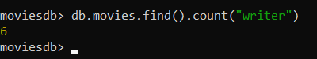

**UPDATE AN ACTOR NAMED "SAMUEL L. JACKSON" TO THE MOVIE "PULP FICTION"**

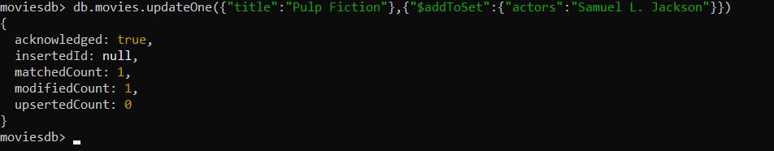

**FIND ALL MOVIES THAT HAVE A SYNOPSIS THAT CONTAINS THE WORD "GANDALF"**

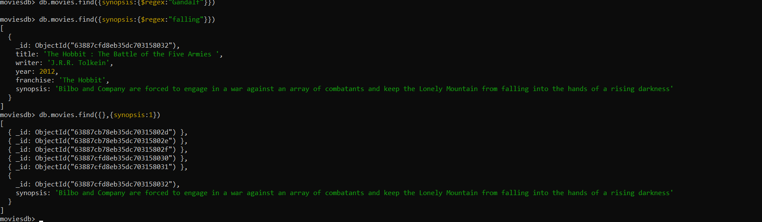

**DISPLAY THE MOVIE COLLECTION BASED ON YEAR IN DESCENDING ORDER.**

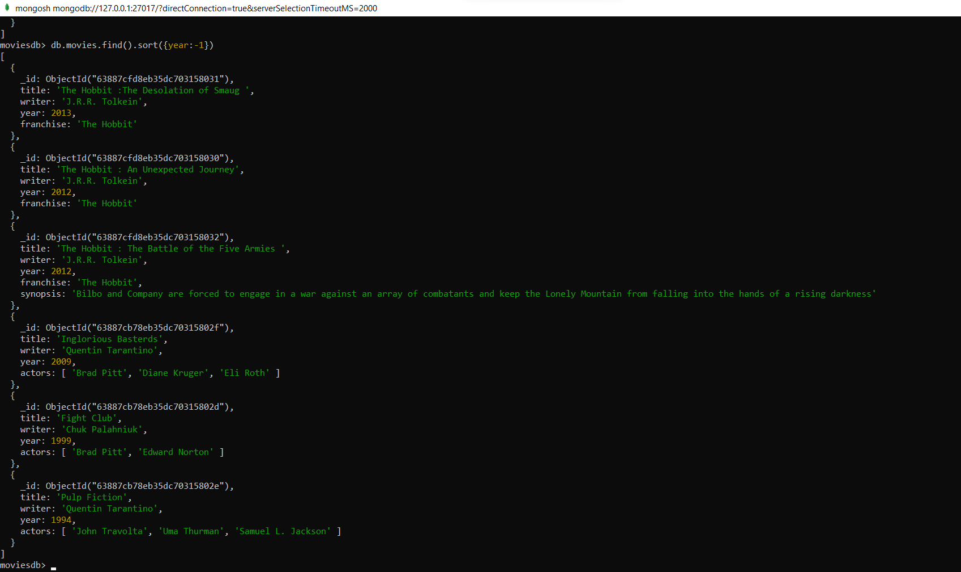

**DISPLAY LAST TWO RECENT MOVIE.**

